E-Commerce Database Project Documentation

Data Retrieval

SELECT * FROM users;

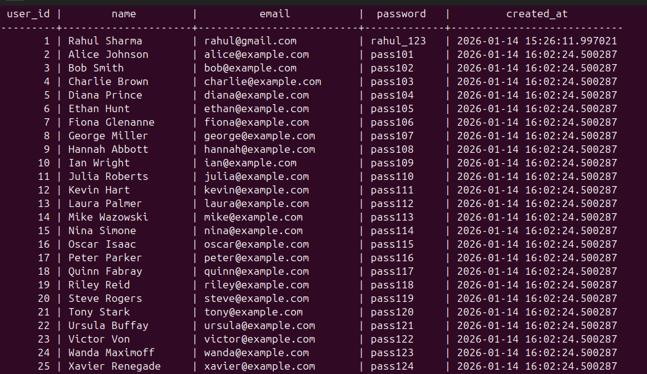

SELECT product_name, price FROM products WHERE price > 1000;
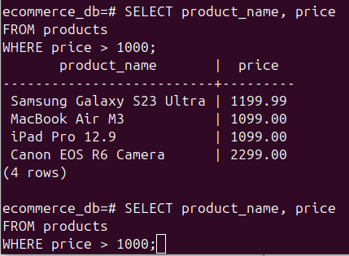

SELECT product_name FROM products WHERE stock = 0;

